A



Project Report On

**CLASSIC WATCH ONLINE SELLING**

**6th Semester**

IN **B.C.A**

SUBMITTED BY

**RAHUL SHARMA**

**(17BCA096) &**

**ANANT PIPARIYA**

**(17BCA079)**

SUBMITTED TO

**DEPARTMENT OF COMPUTER SCIENCE M & N VIRANI SCIENCE COLLEGE, RAJKOT**

**INTERNAL GUIDE:**

Jignesh Hirapara

Ripal Ranpara

## Table of Contents

|  |  |  |  |
| --- | --- | --- | --- |
| **Sr. No** |  | **Subject** | **Page Number** |
|  |  |  |  |
| **1** |  | **Introduction** | 3 |
|  |  |  |  |
| **2** |  | **Modules** | 5 |
|  |  |  |  |
| **3** |  | **Project Planning & Analysis** | 6 |
|  |  |  |  |
| **4** |  | **DFD’S & Flow Chart** | 8 |
|  |  |  |  |
| **5** |  | **System Design** | 16 |
|  |  |  |  |
| **6** |  | **Screen Shot & Coding** | 17 |
|  |  |  |  |
| **7** |  | **Admin Panel** | 27 |
|  |  |  |  |
| **8** |  | **Software Testing** | 38 |
|  |  |  |  |
| 9 |  | **Summary & Conclusion** | 41 |

**(1) Introduction**

### Introduction

* + - Classic watch is an online selling website in which buyer could buy a wrist watch online
    - This site could help customers to buy a new watch easily.
    - User can buy a watch by category like Analog watch, Digital watch, Hybrid watch, Touch screen watch.
    - Also user can buy a watch by Watch Style Causal watch, Dress watch, Fashion watch, luxury watch.
    - User can buy a watch based on movement like Quartz, Mechanical Automatic and Solar.
    - Online watch buying website is very easy to access and users could save the time and he/she can access website everywhere.
    - User is no need to visit a watch shop/store. Sometime watch shop is close but users can shop 24x7 using our website. The online system is available to use anytime
    - They just need internet and smart device like Smartphone and laptop etc.
* User is no need to visit a watch shop/store. Sometime watch shop is close but users can shop 24x7 using our website. The online system is available to use anytime.
* They just need internet and smart device like Smartphone and laptop etc.

**(2) Modules**

**MODULES OF CLASSIC WATCH**

* Admin Profile : admin can see all the products, add a new product, change the price of product and also delete old products. Admin give discount on product.
* Customer profile : customer can see various products ,buy a product , add product into cart ,delete from cart and they can have many types of payment gateway.
* Log in / create new account : user can log in in our website or they can create a new account.
* Payment Gatway: user can do three way to payment in our website like

Cash On Delivery, Credit Card and Debit Card.

**(3) Project Planning & Analysis**

**PROJECT PLANNING**

Project Title : Classic Watch Online Selling

Starting Date : 05-07-2019

Ending Date : 20-03-2020

### Project Scheduling

* The toughest part of software development can be said to Planning and scheduling. This project has many features like add, update, delete a watch.
* Scheduling of the project implies the adequate resources are available or not. Each small task of the project is scheduled by time, person and many other factors. Gantt chart is a type of bar chart. Here, the Gantt chart for various activities to develop a project is described.

### Software requirement specifications (SRS)

#### Functional Requirements:

##### System Requirements (Hardware, Software)

The requirements for development and implementation of this application are categorized into following categories.

##### Hardware Requirements

**Client side**

|  |  |  |
| --- | --- | --- |
| **Category** | **Requirement** |  |
| Device | Android supported | |

**Developer side**

|  |  |  |
| --- | --- | --- |
| **Category** | **Requirement** |  |
| RAM | 256 MB | |
| Space on disk | Minimum 256MB | |

**User side**

|  |  |
| --- | --- |
| **Category** | **Requirement** |
| Chrome | Our project support any chrome version |

**Developer side**

|  |  |
| --- | --- |
| **Category** | **Requirement** |
| OS | Windows / Linux |
| Technologies used | Php , html ,css |

**(4) DFD’S & Flow Chart**

#### DFD:-

#### ZERO Level Diagram:-

**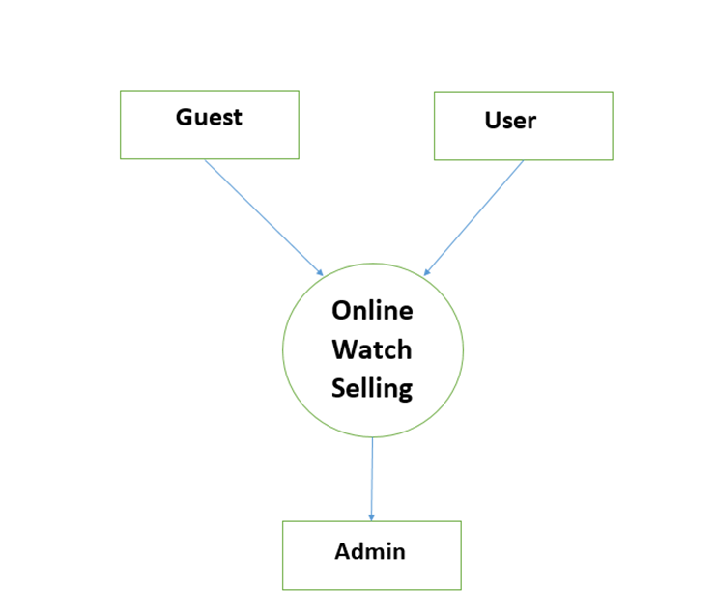**

#### First Level Diagram:-

**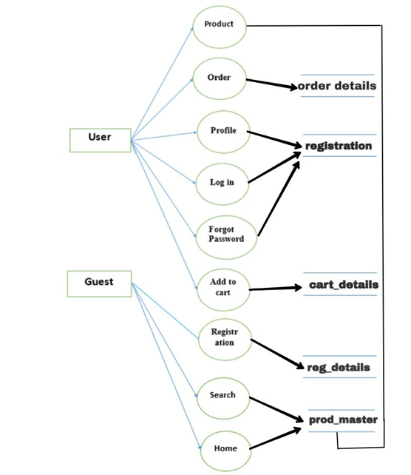**

#### Second Level Diagram:-

**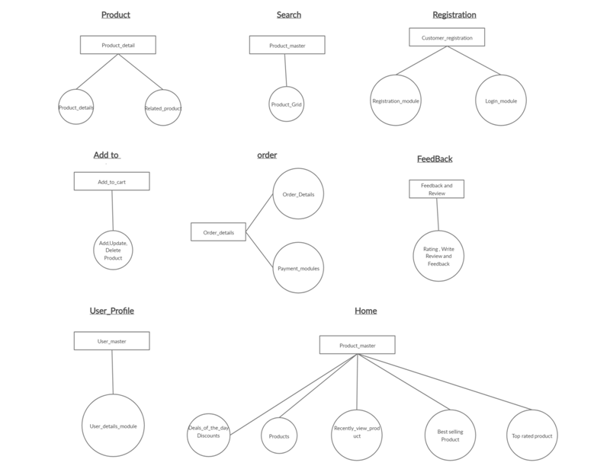**

#### Use Case Diagram :-

#### H:\project_5th\use_case_diagram.jpg

#### Admin Activity:-

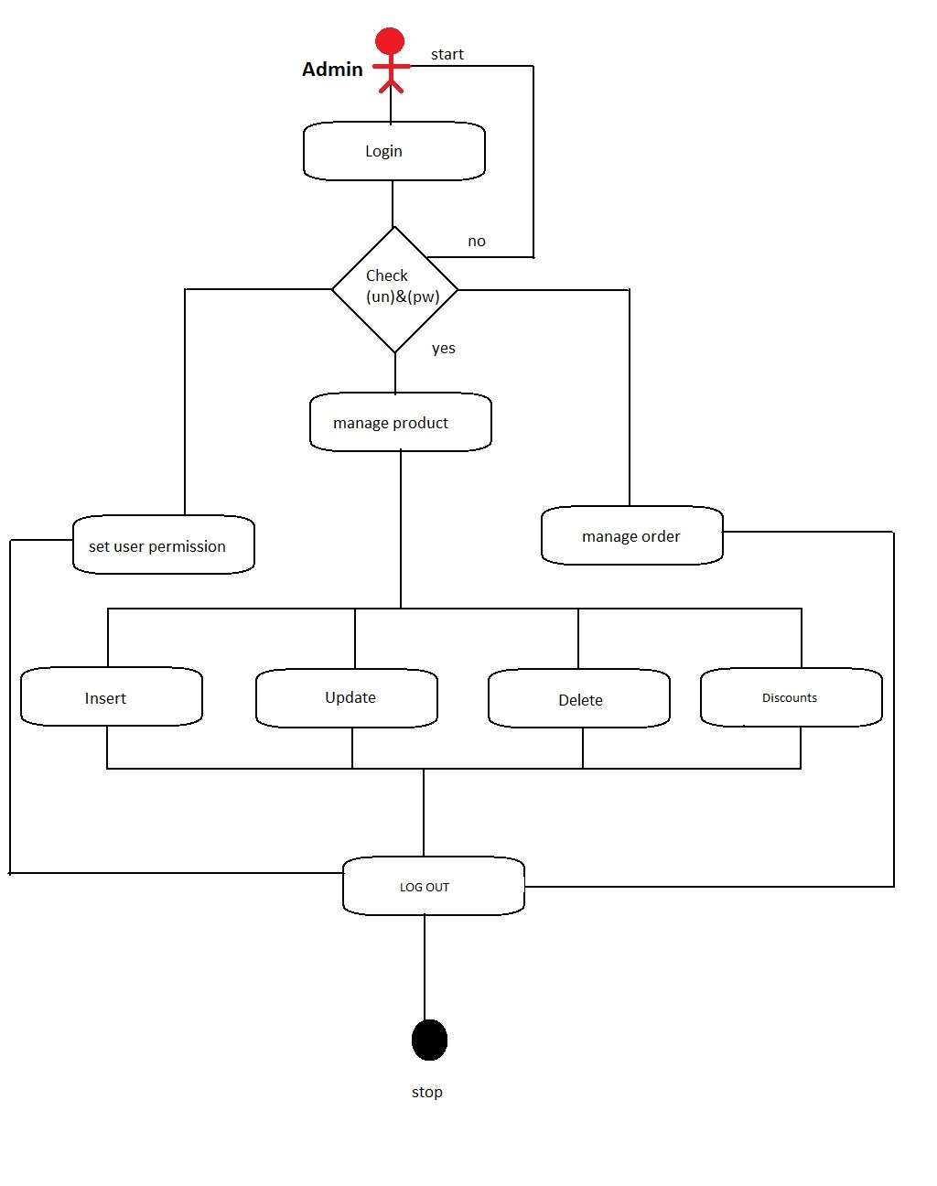

#### Guest Log In :-

#### guest_login.jpg

#### Guest Activity :-

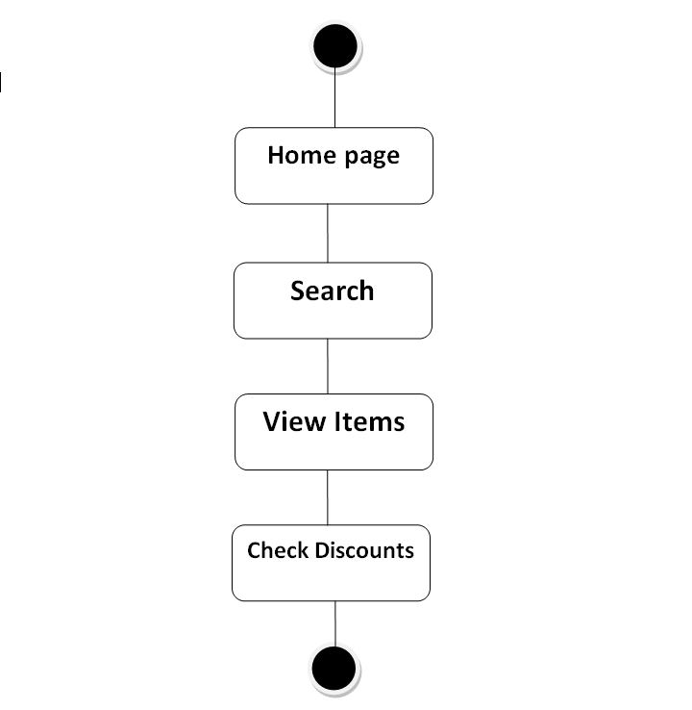

#### E R Diagram:-

#### E R diagram.jpg

**(5) System Design**

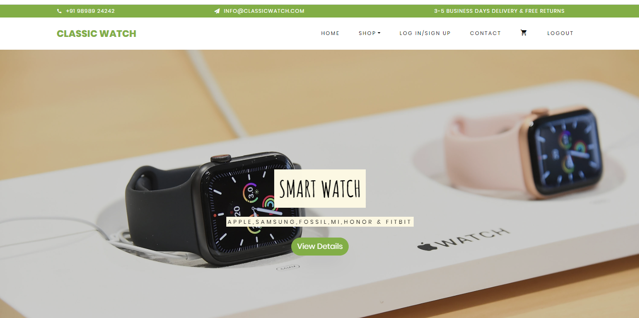

### Introduction:-

* + - Systems design is the process of defining the architecture, components, modules, interfaces, and data for a system to satisfy specified requirements.

### Logical Design:-

* + - The logical design of a system pertains to an abstract representation of the data flows, inputs and outputs of the system.
    - In the context of systems design are included. Logical design includes Zero level ,First level diagram and Use case Diagrams.

**(6) Screen Shot & Coding**

# LOG IN PAGE:

**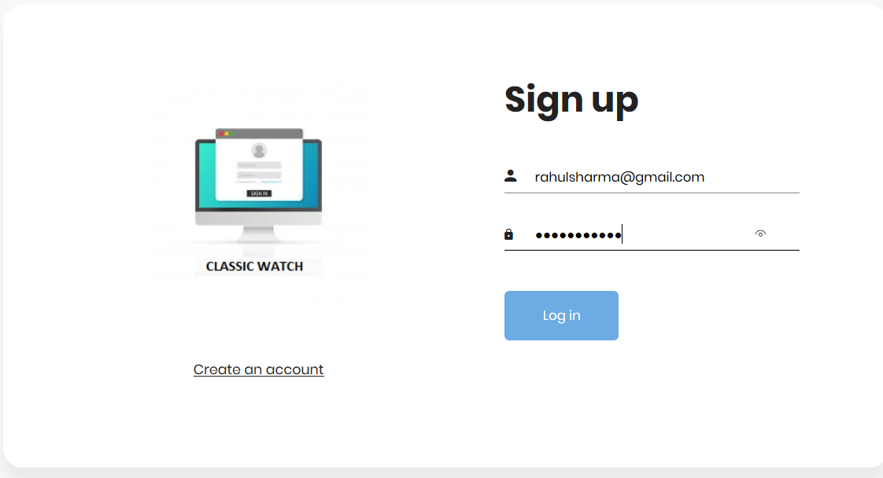**

##### Description :

* There are many types of features available in our **CLASSIC WATCH WEBSITE**
* User can see different types of watch categories like Smart Watch, Automatic Watch, Smart Band,Steel Belt Watch, Premium Watch, Leather Watch.To see any type of watch go to that category.

#### Log In Logic :

**<?php**

**include 'conn.php';**

**if(isset($\_POST['signin']))**

**{**

**if($\_SERVER["REQUEST\_METHOD"] == "POST")**

**{**

**$myusername = $\_POST['your\_name'];**

**$mypassword = $\_POST['your\_pass'];**

**$sql = "SELECT \* FROM USER\_MASTER WHERE Email\_Id = '$myusername' and Password = '$mypassword'";**

**$result=mysqli\_query($con,$sql);**

**$r=mysqli\_num\_rows($result);**

**//echo $r;**

**while($data=mysqli\_fetch\_assoc($result))**

**{**

**if($myusername == $data['Email\_Id'])**

**{**

**session\_start();**

**$\_SESSION["user"] = "User Exit";**

**header("Location: ..\index.php?user\_id='".$data['User\_id']."' ");**

**}**

**else**

**{**

**//header("Location: already\_user\_page.php");**

**}**

**}**

**}**

**}**

**?>**

# SIGN UP PAGE :

# C:\Users\HP\Pictures\Screenshots\Screenshot (116).png

#### Logic :

**<?php**

**session\_start();**

**include 'conn.php';**

**if(isset($\_POST['signup']))**

**{**

**$nm=$\_POST['name'];**

**$mn=$\_POST['phonenumber'];**

**$em=$\_POST['email'];**

**$psw=$\_POST['pass'];**

**$rpsw=$\_POST['re\_pass'];**

**$bdt=$\_POST['birthdate'];**

**$add=$\_POST['address'];**

**$city=$\_POST['city'];**

**$pin=$\_POST['pincode'];**

**if (!is\_numeric($mn) )**

**{**

**echo "<script>alert('please valid number');</script>";**

**}**

**else if (strlen($mn)!=10)**

**{**

**echo "<script>alert('please valid number');</script>";**

**}**

**Else**

**{**

**echo "<script>alert('please valid number');</script>";**

**}**

**$q2="insertintouser\_master(Name,Mobile\_Number,Email\_Id,Password,Confirm\_password,Birthdate,Addres,City,Pincode) values('$nm','$mn','$em','$psw','$rpsw','$bdt','$add','$city','$pin')";**

**if(mysqli\_query($con,$q2))**

**{**

**$\_SESSION['login']=$\_POST['email'];**

**$\_SESSION['user\_id']=$\_POST['User\_Id'];**

**header("Location: already\_user\_page.php");**

**}**

**else**

**{**

**header("Location: log\_in\_page.php");**

**/\*echo "<script>alert('Product added');</script>"\*/;**

**}**

**}**

**?>**

# CATEGORY OF WATCH :

**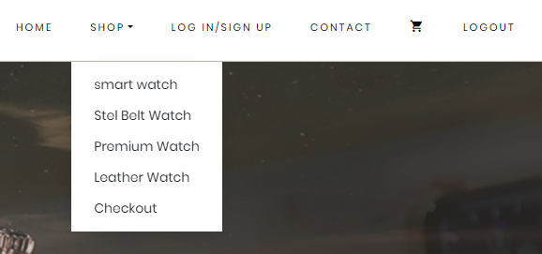**

##### CATEGORYY.PNG

##### Description :

In our Website , you can see many types of categories in watch

# ADD_TO_CART.PNGADD TO CART:

#### Logic :

**<?php**

**include "conn.php";**

**if (isset($\_POST['addcart'])) {**

**$pid=$\_POST['pid'];**

**$quantity=$\_POST['quantity'];**

**$pprice=$\_POST['pprice'];**

**$uid='128';**

**$to=$pprice\*$quantity;**

**$query="INSERT INTO cart(uid, pid, qty, pri, tot) VALUES**

**('$uid','$pid','$quantity','$pprice','$to')";**

**Mysqli\_query($con,$query);**

**}**

**?>**

# DELETE.PNGDELETE PRODUCT:

* **Logic :**

# <?php

# include "conn.php";

# $myid=$\_GET['id'];

# $q3 = "delete from cart where cid=$myid";

# if ($q3<1)

# {

# mysqli\_query($con,$q3);

# header("Location: cart.php");

# }

# else

# {

# echo "not deleted";

# }

# 

# ?>

# PAYMENT GATEWAY:

# Cash On delivery:

# C:\Users\HP\Pictures\Screenshots\Screenshot (118).png

* **Logic :**

# <?php

# include "conn.php";

# if (isset($\_POST['placeorder'])) {

# $name=$\_POST['name'];

# $city=$\_POST['city'];

# $add=$\_POST['address'];

# $pin=$\_POST['pincode'];

# $mn=$\_POST['phone'];

# $email=$\_POST['email'];

# $tot=$\_POST['total'];

# $pay=$\_POST['payment'];

# $query="INSERT INTO ordersummary( Name , City , Address , Pincode,PhoneNumber,Email,

# Total ,Payment\_method ) VALUES

# ('$name','$city','$add','$pin','$mn','$email','$tot','$pay')";

# if (mysqli\_query($con,$query)) {

# 

# echo "<script>alert('order accpected');</script>";

# header("Location: Ordersummary.php");

# 

# }

# else

# {

# header("Location: checkout.php");

# echo "<script>alert('order rejected');</script>";

# }

# }

# ?> $pay=$\_POST['payment'];

# $query="INSERT INTO ordersummary( Name , City , Address , Pincode,PhoneNumber,Email,

# Total ,Payment\_method ) VALUES

# ('$name','$city','$add','$pin','$mn','$email','$tot','$pay')";

# if (mysqli\_query($con,$query)) {

# 

# echo "<script>alert('order accpected');</script>";

# header("Location: Ordersummary.php");

# 

# }

# else

# {

# header("Location: checkout.php");

# echo "<script>alert('order rejected');</script>";

# }

# }

# ?>

# Debit Card:

* **Logic :**

**<?php**

**include "conn.php"**

**if (isset($\_POST['submit']))**

**{**

**$cnum=$\_POST['cnum'];**

**$cvv=$\_POST['cvv'];**

**$expdate=$\_POST['expdate'];**

**$cname=$\_POST['cname'];**

**$query = "INSERT INTO `debitcard`**

**( `cardnumber`, `cvv`, `expdate`, `cname`) VALUES ( '$cnum', '$cvv', '$expdate', '$cname')";**

**if (mysqli\_query($con,$query))**

**{**

**header("Location: Ordersummary.php");**

**}**

**else**

**{**

**header("Location: debitcarddetails.php");**

**}**

**}**

**?>**

# Credit Card:

# 

* **Logic :**

# <?php

# include "conn.php";

# if (isset($\_POST['submit'])) {

# $cnum=$\_POST['cnum'];

# $cvv=$\_POST['cvv'];

# $expdate=$\_POST['expdate'];

# $cname=$\_POST['cname'];

# 

# $query="INSERT INTO `creditcard` ( `cardnumber`, `cvv`, `expdate`, `cname`) VALUES ( '$cnum', '$cvv', '$expdate', '$cname')";

# if (mysqli\_query($con,$query)) {

# 

# header("Location: Ordersummary.php");

# 

# 

# 

# }

# else

# {

# 

# 

# header("Location: creditcarddetails.php");

# }

# 

# }

# ?>

# Order Summary:

# C:\Users\HP\Pictures\Screenshots\Screenshot (104).png

##### Logic :

# <?php

# include "conn.php";

# $s="SELECT \* FROM ordersummary ";

# $result=mysqli\_query($con,$s);

# $r=mysqli\_num\_rows($result);

# //echo $r;

# while($data=mysqli\_fetch\_assoc($result))

# {

# 

# 

# echo "<form method='POST'><tr><td style=' padding:5px;'>".$data['Order\_id']." </td>

# <td style=' padding:5px;'>".$data['Name']."</td>

# <td style=' padding:5px;'>".$data['City']."</td>

# <td style=' padding:5px;'>".$data['Address']."</td>

# <td style=' padding:5px;'>".$data['PhoneNumber']."</td>

# <td style=' padding:5px;'>".$data['Email']."</td>

# 

# <td style=' padding:5px;'>".$data['Total']."</td>

# <td style=' padding:5px;'>".$data['Payment\_method']."</td>

# 

# </form>";

# 

# }

# ?>

**(7) Admin Panel**

# ADMIN PANEL :

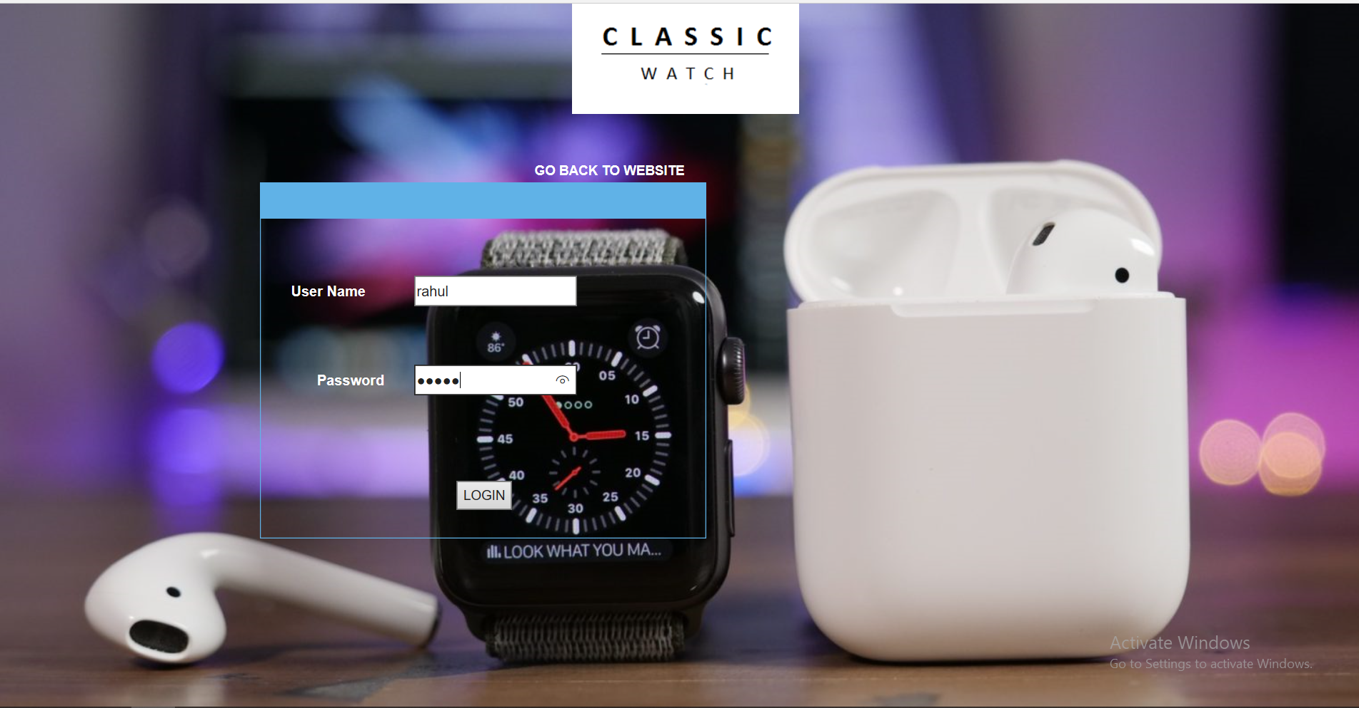

##### Logic :

# <?php include('function.php'); ?>

# <?php

# $\_SESSION['loginstatus']="";

# if(isset($\_POST["sbmt"]))

# {

# $cn=makeconnection();

# $s="select \* from admin\_login\_table where Admin\_Login\_id ='" . $\_POST["t1"] . "' and Admin\_password ='" . $\_POST["t2"] ."'";

# 

# $q=mysqli\_query($cn,$s);

# $r=mysqli\_num\_rows($q);

**$data=mysqli\_fetch\_array($q);**

**mysqli\_close($cn);**

**if($r>0)**

**{**

**$\_SESSION["Admin\_Login\_id"]= $\_POST["t1"];**

**$\_SESSION["Admin\_password"]=$data[2];**

**$\_SESSION['loginstatus']="yes";**

**header("location:index.php");**

**}**

**else**

**{**

**echo "<script>alert('Invalid User Name or Password');</script>";**

**}**

**}**

**?>**

# ADD PRODUCT :

**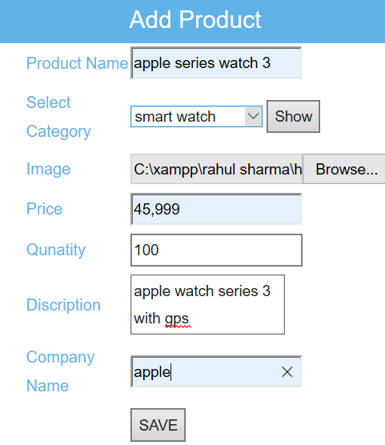**

##### Logic :

**<?php**

**if(isset($\_POST["sbmt"]))**

**{**

**$cn=makeconnection();**

**$target\_dir = "productimage/";**

**$target\_file = $target\_dir.basename($\_FILES["t4"]["name"]);**

**$uploadok = 1;**

**$imagefiletype = pathinfo($target\_file, PATHINFO\_EXTENSION);**

**$s="insert into product\_table(Product\_name,Category\_id ,image ,Price ,Quantity ,Description ,Company\_name) values('" . $\_POST["t1"] ."','" . $\_POST["t2"] ."','" . basename($\_FILES["t4"]["name"]) . "','". $\_POST["t8"] . "','" . $\_POST["t10"] ."','" . $\_POST["t7"] ."','" . $\_POST["t11"] ."')";**

**mysqli\_query($cn,$s);**

**$\_SESSION['Product\_id']= $\_POST['Product\_id'];**

**mysqli\_close($cn);**

**echo "<script>alert('Product added');</script>";**

**}**

**?>**

# ADD CATEGORY :

# C:\Users\HP\Pictures\Screenshots\Screenshot (106).png

##### Logic :

**<?php**

**if(isset($\_POST["sbmt"]))**

**{**

**$cn=makeconnection();**

**$s="insert into categories\_types(Category\_Name ) values('" . $\_POST["t1"] ."')";**

**mysqli\_query($cn,$s);**

**$\_SESSION['Category\_id']= $\_POST['Category\_id'];**

**mysqli\_close($cn);**

**echo "<script>alert('Record Save');</script>";**

**}**

**?>**

# DELETE PRODUCT :

**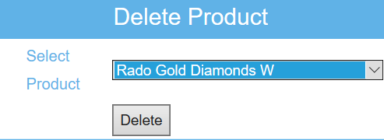**

##### Logic :

**<?php**

**if(isset($\_POST["sbmt"]))**

**{**

**$cn=makeconnection();**

**$s="delete from Product\_Table where Product\_id='" . $\_POST["t1"] . "'";**

**mysqli\_query($cn,$s);**

**mysqli\_close($cn);**

**echo "<script>alert('Record Delete');</script>";**

**}**

**?>**

# DELETE CATEGORY :

# C:\Users\HP\Pictures\Screenshots\Screenshot (108).png

##### Logic :

**<?php**

**if(isset($\_POST["sbmt"]))**

**{**

**$cn=makeconnection();**

**$s="delete from CATEGORIES\_TYPES where Category\_id='" . $\_POST["t1"] . "'";**

**mysqli\_query($cn,$s);**

**mysqli\_close($cn);**

**echo "<script>alert('Record Delete');</script>";**

**}**

**?>**

# UPDATE PRODUCT :

# C:\Users\HP\Pictures\Screenshots\Screenshot (110).png

# Logic :

**<?php**

**if(isset($\_POST["sbmt"]))**

**{**

**$cn=makeconnection();**

**$f1=0;**

**$target\_dir = "productimage/";**

**$target\_file = $target\_dir.basename($\_FILES["t4"]["name"]);**

**$uploadok = 1;**

**$imagefiletype = pathinfo($target\_file, PATHINFO\_EXTENSION);**

**if(move\_uploaded\_file($\_FILES["t4"]["tmp\_name"], $target\_file)){**

**$f1=1;**

**}**

**}**

**?>**

**<?php**

**if(isset($\_POST["sbmt"]))**

**{**

**$cn=makeconnection();**

**if (empty($\_FILES['t2']['name'])) {**

**$s="update product\_table set Product\_name='" .**

**//UPDATE\_QUERY**

**}**

**else**

**{**

**$s="update product\_table set Product\_name='" . $\_POST["t1"] ."',Category\_id='" . $\_POST["t2"] . "',image='" . basename($\_FILES["t4"]["name"]) . "',Price='" . $\_POST["t8"] . "',Quantity='" . $\_POST["t10"] . "',Description='" . $\_POST["t7"] . "',Company\_name='" . $\_POST["t11"] . "' where Packid='" . $\_POST["s1"] . "'";}**

**mysqli\_query($cn,$s);**

**mysqli\_close($cn);**

**echo "<script>alert('Record Update');</script>";**

**}**

**?>**

# UPDATE CATEGORY:

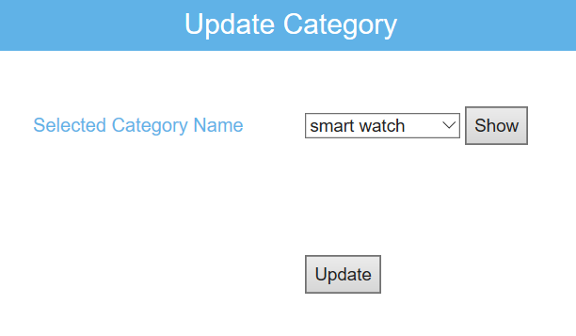

* Logic :

**<?php**

**if($\_SESSION['loginstatus']=="")**

**{**

**header("location:loginform.php");**

**}**

**?>**

**<?php include('function.php'); ?>**

**<?php**

**if(isset($\_POST["sbmt"]))**

**{**

**$cn=makeconnection();**

**$s="update CATEGORIES\_TYPES set Category\_Name='" . $\_POST["t2"] ."' where Category\_id='" . $\_POST["t1"] . "'";**

**mysqli\_query($cn,$s);**

**mysqli\_close($cn);**

**echo "<script>alert('Record Update');</script>";**

**}**

**?>**

**<?php include('top.php'); ?>**

**<!--/sticky-->**

**<div style="padding-top:100px; box-shadow:1px 1px 20px black; min-height:570px" class="container">**

**<div class="col-sm-3" style="border-right:1px solid #999; min-height:450px; margin-top: -78px;">**

**<?php include('left.php'); ?>**

**</div>**

**<div class="col-sm-9">**

**<form method="post">**

**<table style="margin-right: -130px;" border="0" width="500px" height="300px" align="center" class="tableshadow">**

**<tr><td colspan="2" class="toptd">Update Category</td></tr>**

**<tr><td class="lefttxt">Selected Category Name</td><td><select name="t1" required/><option value="">Select</option>**

**<?php**

**$cn=makeconnection();**

**$s="select \* from CATEGORIES\_TYPES";**

**$result=mysqli\_query($cn,$s);**

**$r=mysqli\_num\_rows($result);**

**//echo $r;**

**while($data=mysqli\_fetch\_array($result))**

**{**

**if(isset($\_POST["show"])&& $data[0]==$\_POST["t1"])**

**{**

**echo"<option value=$data[0] selected>$data[1]</option>";**

**}**

**else**

**{**

**echo "<option value=$data[0]>$data[1]</option>";**

**}**

**}**

**mysqli\_close($cn);**

**?>**

**</select>**

**<input type="submit" value="Show" name="show" formnovalidate/>**

**<?php**

**if(isset($\_POST["show"]))**

**{**

**$cn=makeconnection();**

**$s="select \* from CATEGORIES\_TYPES where Category\_id='" .$\_POST["t1"] ."'";**

**$result=mysqli\_query($cn,$s);**

**$r=mysqli\_num\_rows($result);**

**//echo $r;**

**$data=mysqli\_fetch\_array($result);**

**$Category\_id=$data[0];**

**$Category\_Name=$data[1];**

**mysqli\_close($cn);**

**}**

**?>**

# VIEW PRODUCT WITH DETAILS :

# VIEW_PRODUCTS.PNG

# VIEW ORDER :

# 

# VIEW CART WITH DETAILS :

# VIEW_CART.PNGVIEW CUSTEMER DETAILS:

**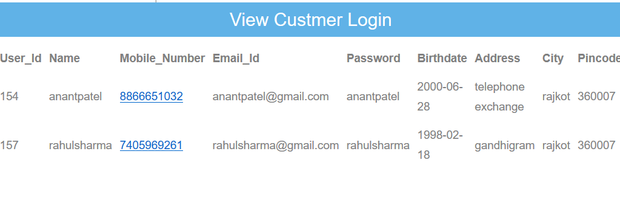**

**(8) Project Testing**

**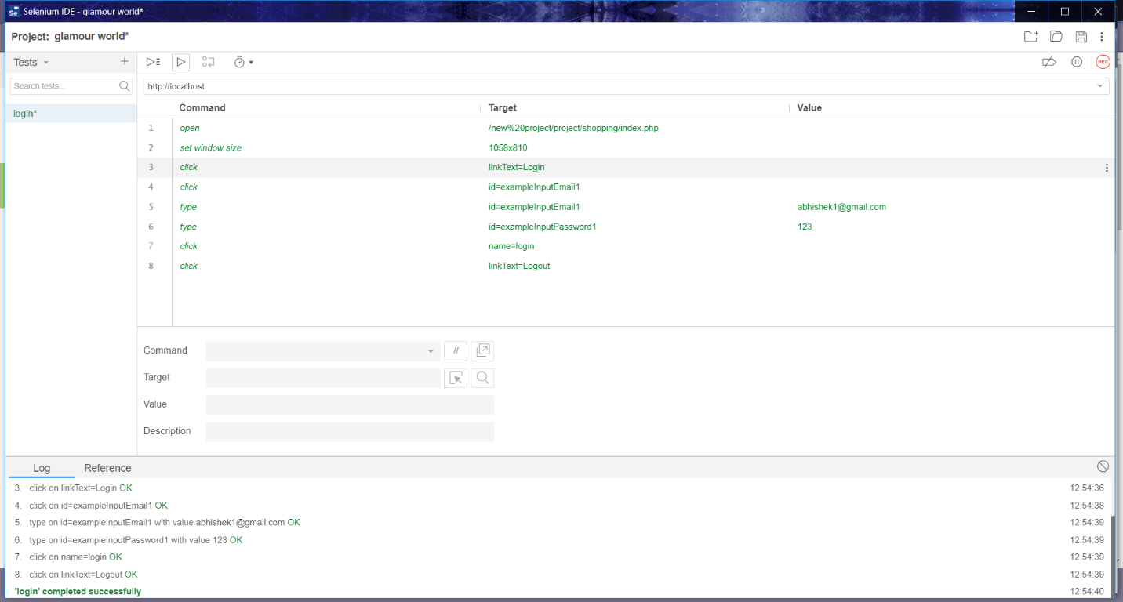**

**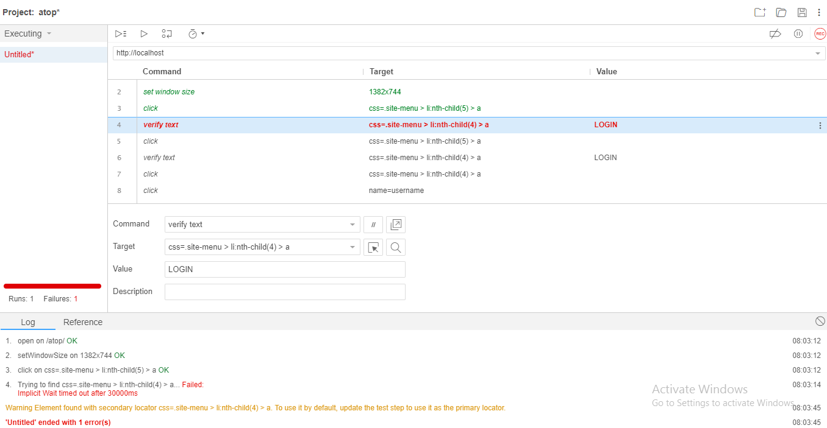**

**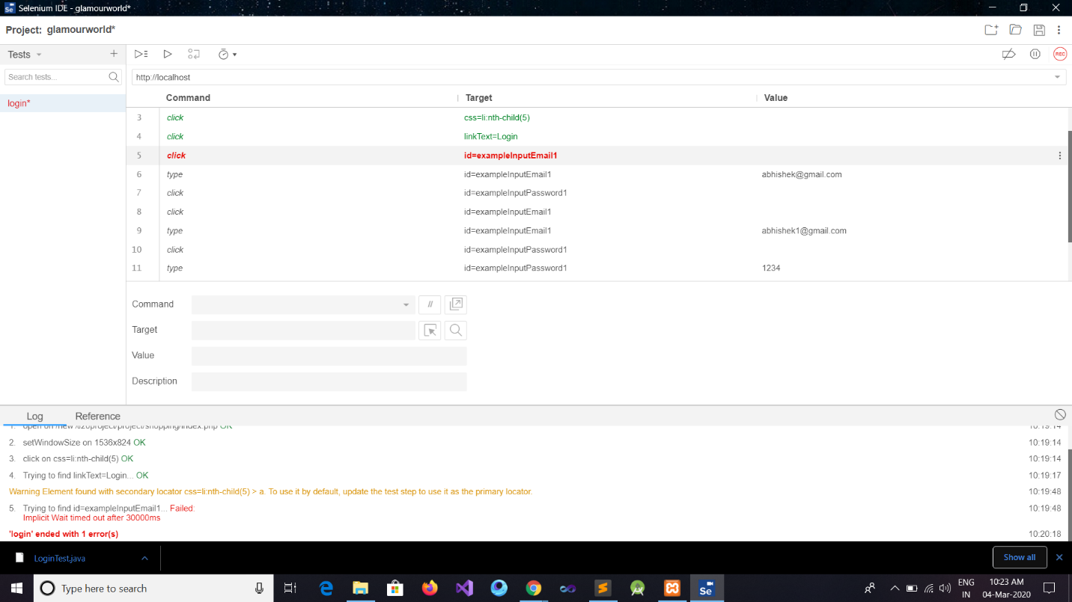**

**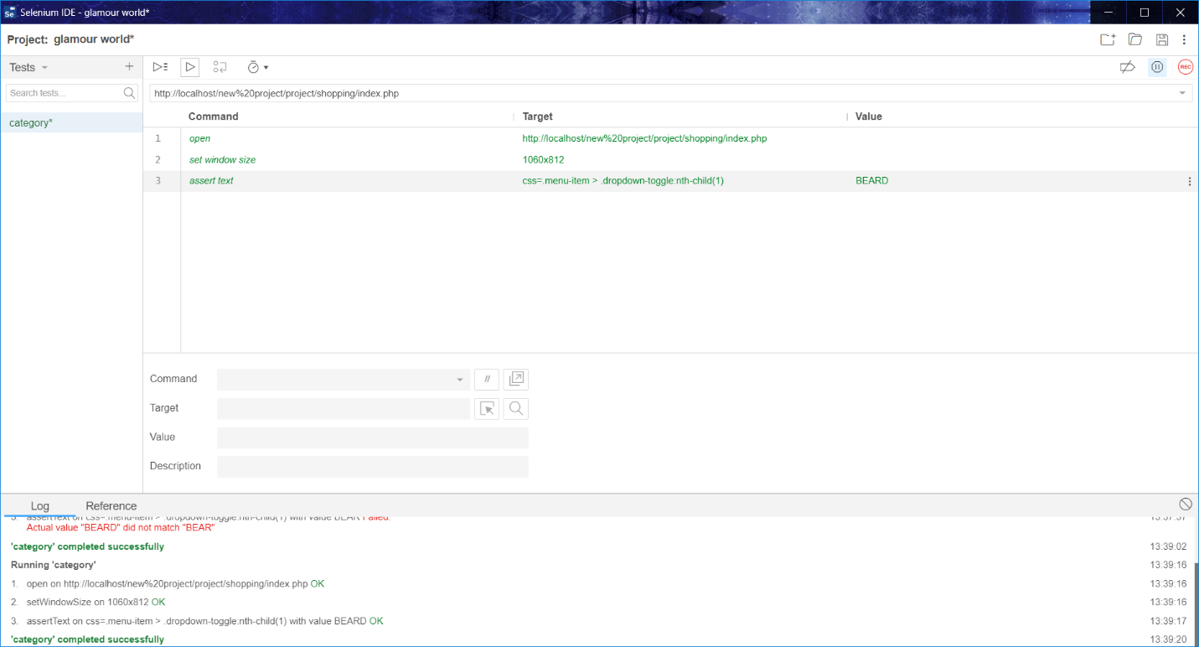**

**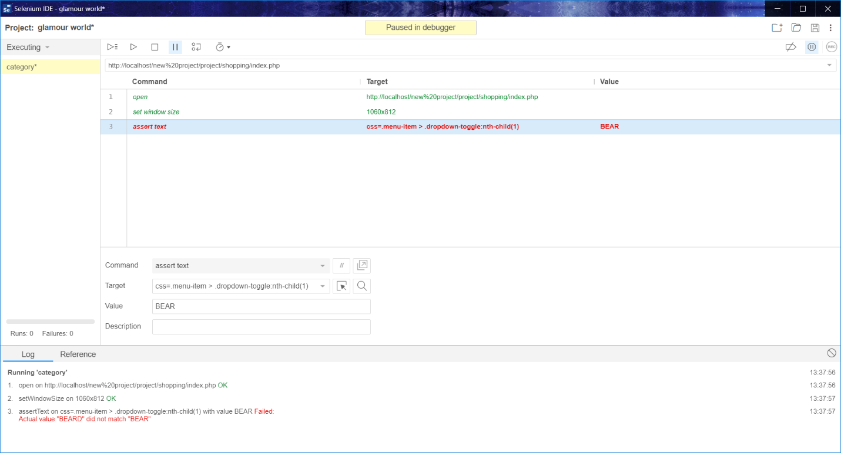**

**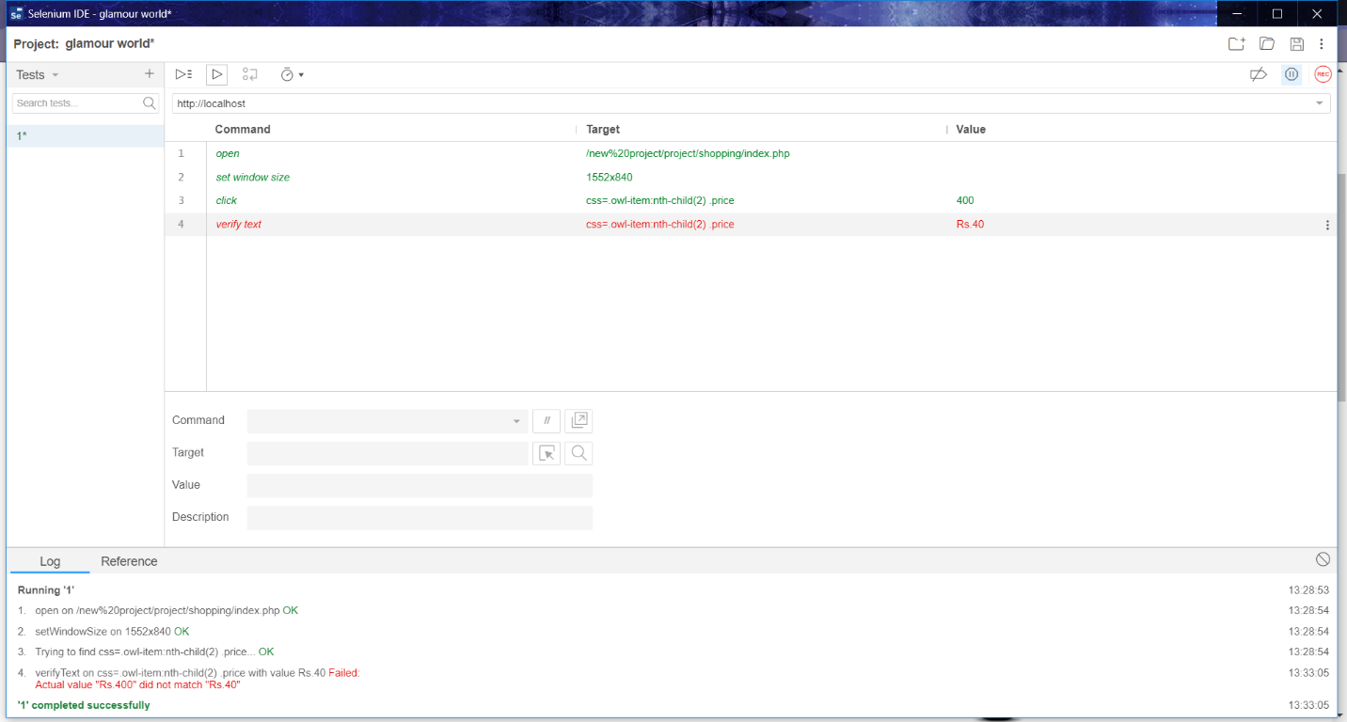**

**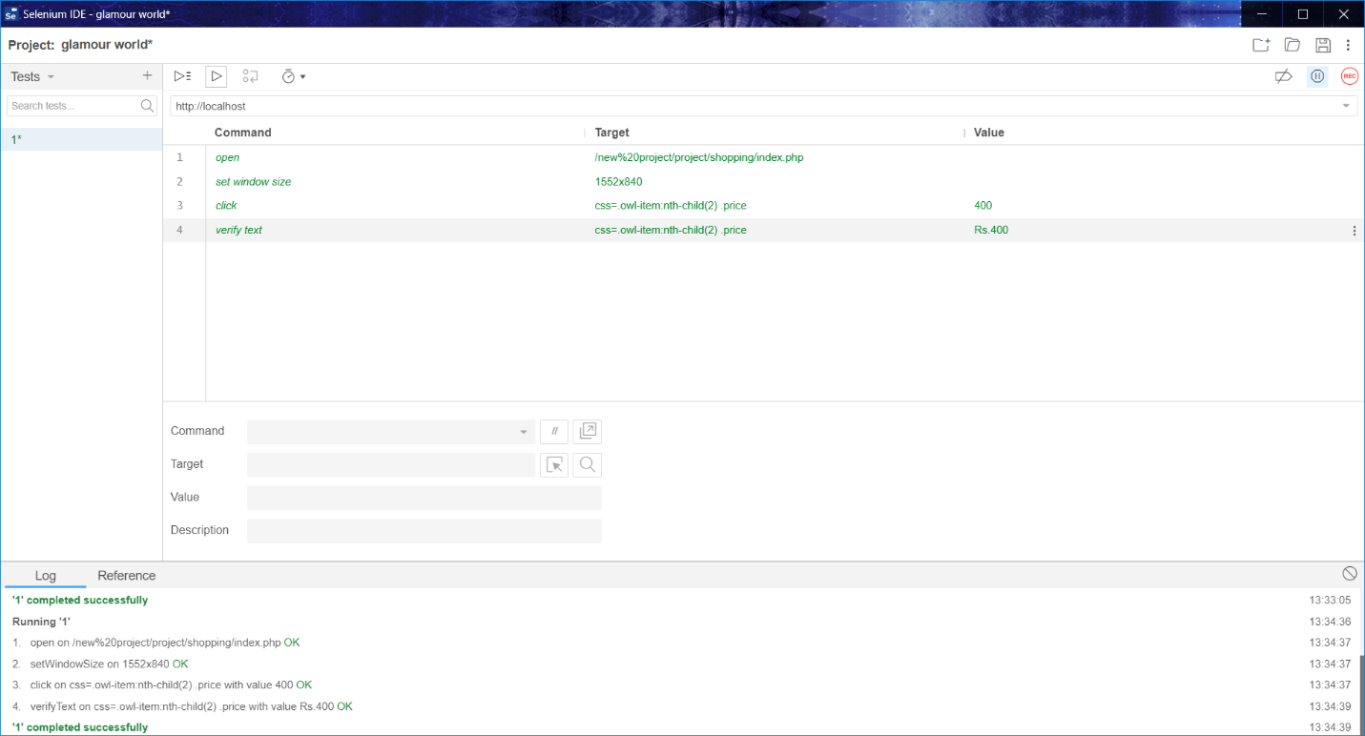**

**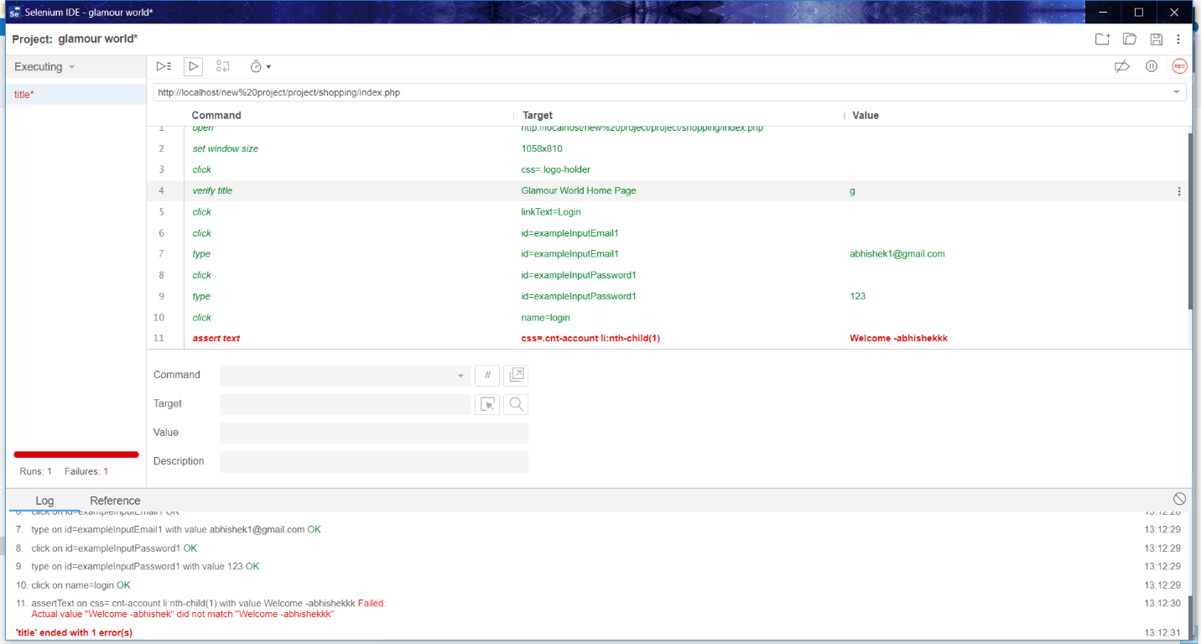**

****

**(9) SUMMARY & CONCLUSION**

* E-Commerce is a great way for business and consumers

To interact internationally.

* The future of E-commerce will drastically progress over the years as the amount of internet users among businesses and consumers grows drastically every year.

* Developing an Website is not an easy task after all, so we have many different problems that occur during the project.
* Most importantly we learned many things during this project. Among which the most important was to learn advanced language like php. Thus this project helped us in many ways.
* Our have a three types of payment method.

1. Cash On Delivery
2. Credit Card
3. Debit Card

**Thank You**

****